^{on} What Child is This –Joseph Sermon 17 December 2017
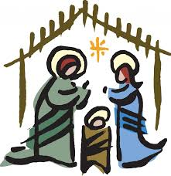
Matthew 1:18-25 Romans 8:14-17

Prayer: May the words of my mouth and the mediations of our hearts… Amen

Today the challenge given is for us to reflect on a person missing from the Christmas Carol ‘What Child Is This’. Like I said last time I preached – when I am preaching this Advent, I am working on a series based on the Carol; ‘What Child Is This?’ ^{off}

I would remind you that the lyrics were written in 1865 by an William C. Dix. The carol is being used because it poses an important question that is worth us spending some time thinking about as we approach Christmas: who this baby in the Bethlehem manger is, while working our way through the various verses.

The carol has a strong focus on Christ – The Christ child, then His mother, Mary, and then shepherds, angels and even two kinds of farm animals. The 3 wise-men are not specifically named, but can be the recognised through the gifts of incense, gold, and myrrh. All the characters that are usually in a Christmas Nativity display are present in the carol except one. Do you know who is missing from the stable scene roll call by name or by referenced action? ^{on} Joseph.
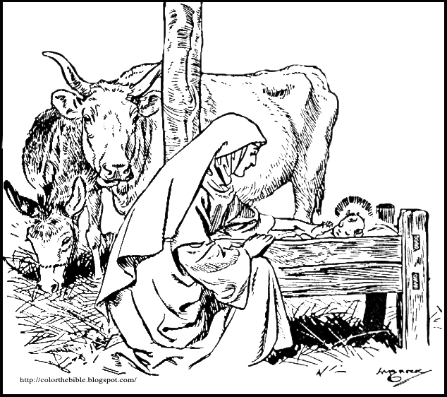

There is no mention of the man who would help raise the "Son of Mary.” Everybody else in the Christmas story gets air time or has a line, but not the ‘one’ man who would love and invest himself in the life of this special child. We can’t be sure, but it seems like Joseph would be ok with this – ok with not much (if any!) fanfare about him, in this carol. ^{off}

In fact, Mark's gospel gave Joseph the same amount of exposure: zero. In Mark, Joseph is never mention or alluded to at all! Zero! The other Gospel writers (M, L and J) all mention Joseph by name, but none of them record him as having a speaking part. While a few of Joseph's actions are recorded during the early years of his relationship with Mary and into Jesus 'early life, none of Joseph's words remain in print within the pages of the Bible. Only Joseph's actions of obedience, care, and presence are mentioned.
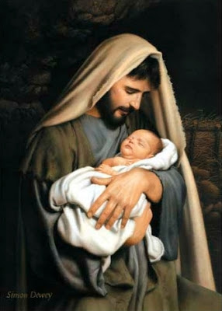

So no, Joseph was not present in the carol. No, Joseph's words are not present in the gospel texts. ^{on} But Joseph was quietly present at the manger. He was present before the manger. He was present after the manger. He was present at least up through Jesus' twelfth birthday as recorded in Luke ^{2:41 -52}. Beyond that account, historians believe Joseph died somewhere between Jesus' teenage years and the beginning of his public ministry at age 30. And during the early childhood years of Jesus' life on earth, not only was this child known as the "Son of Mary" as the carol states but also Jesus was known as the Son of Joseph. ^{off}

What child is this? He is a child adopted by a father who loved Him. How do we know Jesus was adopted by Joseph? There are clues all throughout the places in the Bible that do mention Joseph. We heard Matthew version this morning. There were re two places that gave us clues that Joseph, although not the birth father of Jesus, became his adoptive father. 1. The angel of the Lord told Joseph in the dream: "She will bear a son, and you shall call his name Jesus ….And he called his name Jesus." ^{Mt1:21, 25}
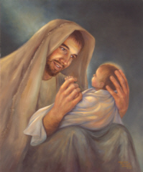

The naming of a child was the responsibility of the father. The intention of God was for Joseph to adopt Jesus as his son and become his earthly father. When Jesus was born in Bethlehem on that Christmas night, Joseph named the child, his adopted child, Jesus. ^{on} It was his responsibility as his adoptive father. On the night Jesus was born, not only did Joseph name Jesus but it’s very likely that he took this new-born baby and symbolically placed Jesus across his knees.

Such a symbolic act was the way a first –century husband in biblical days acknowledged the legitimacy of his new-born descendant. Subsequently, for a man to place someone else's child across his knees was a sacred and symbolic act signifying adoption. Although the Bible does not state explicitly that Joseph did this, it is highly probable that Joseph named Jesus and laid the babe across his knees claiming his legacy and adopting the Son of Mary as his own. ^{off}

Joseph's wife, Mary, certainly viewed her husband as Jesus's father. Remember the story from when Jesus was 12 years old? The family went to Jerusalem to celebrate the Passover Feast? On their way home, his parents couldn’t find him, they rushed back to Jerusalem, and Luke tells us: "And when his parents saw him, they were astonished. And his mother said to him, ‘Son, why have you treated us so? Behold, your father and I have been searching for you in greatdistress."^{Luke2:48} -
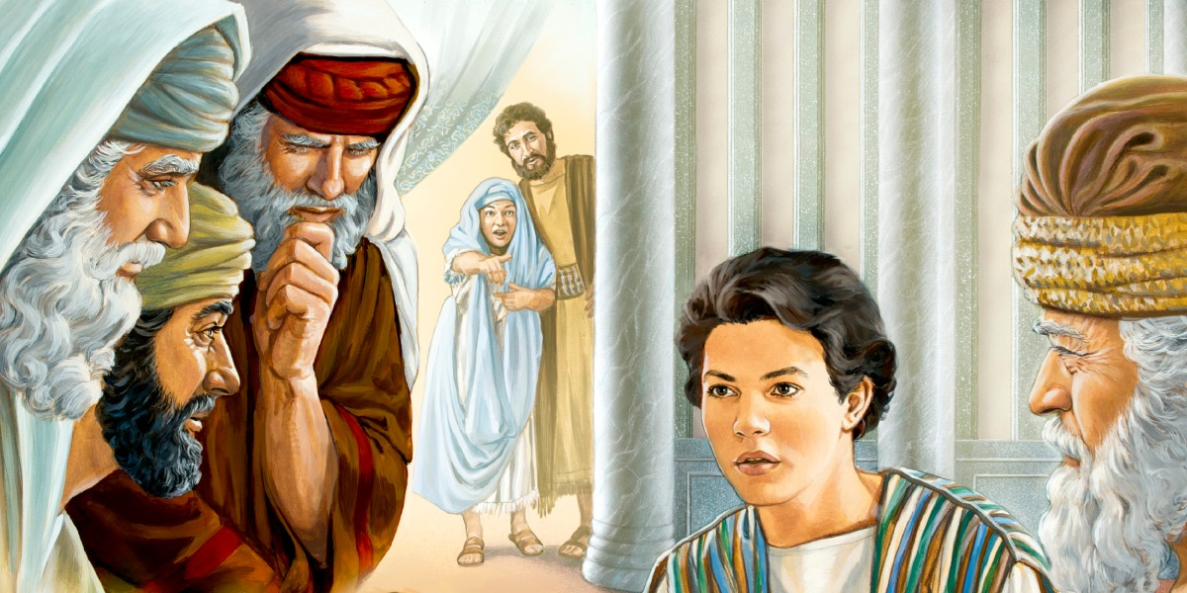

^{on} Luke identifies both Mary and Joseph as Jesus' parents. Mary, Jesus' birth mother, calls her husband, Joseph, Jesus' "father”. It is clear Joseph adopted Jesus as his son, and it’s how Jesus was known in his childhood and into his adult life. ^{off}

Another clue is given in John's gospel when Jesus calls his disciples to follow him and later into his public ministry. "The next day Jesus decided to go to Galilee. He found Philip… …Philip found Nathanael and said to him: ‘We have found him of whom Moses in the Law and the prophets wrote, Jesus of Nazareth, the son of Joseph " ^{John1:43 -45}Or later in John^{6:41 -42} … "Is not this Jesus, the son of Joseph, whose father and mother we know?

Everybody who knew Jesus recognized him as Joseph's son. Joseph had adopted Jesus as his son from day one. What child is this? One of the characteristics that gives an answer is found in the reflection of his earthly father, Joseph. Jesus would become the One who adopts/ names us as part of His own family.

Paul writes about this characteristic of the Jesus-who would grow from the baby in the manger to the God that was willing not only to die for the rescue of His creation, but also to lay all people across His knees to call them as His own, as he bought their freedom from the slavery of sin, death, Satan, and hell. Gal ^{4:4 -7}

"But when the fullness of time had come, God sent forth his Son, born of woman, born under the law, to redeem those who were under the law, so that we might receive adoption as sons. ^{on} And because you are sons, God has sent the Spirit of his Son into our hearts, crying, ‘Abba! Father!' So you are no longer a slave, but a son, and if as on, then an heir through God."
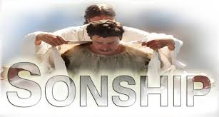

What child is this? He is the one who makes adoption into His family possible. ^{off} And adoption leads to our salvation which includes our freedom from sin. That is what Joseph was told to name his adoptive Son when He would be born. Remember what the angel of the Lord said to Joseph in his dream. Mt^{1:21}

"Joseph, son of David, do not fear to take Mary as your wife, for that which is conceived in her is from the Holy Spirit. She will bear a son, and you shall call his name Jesus, for he will save his people from their sins.”

The name of Jesus means "God saves". What God saves, God adopts as His own and for His own by the power of the Holy Spirit. Our second scripture from Paul to the Romans ^{8:14 -17} this morning said:

"For all who are led by the Spirit of God are sons of God. For you did not receive the spirit of slavery to fall back into fear, but you have received the Spirit of adoption as sons, by whom we cry, ‘Abba! Father!' The Spirit himself bears witness with our spirit that we are children of God, and if children, then heirs —heirs of God and fellow heirs with Christ, provided we suffer with him in order that we may also be glorified with him ."
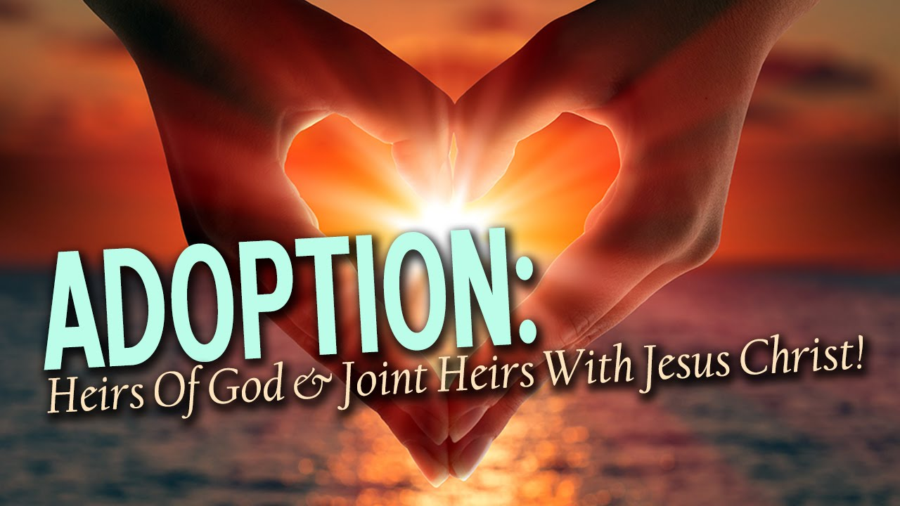

Paul expands on ^{on} our adoption into God's family in his letter to the Ephesian church^{1:5}. It is after our adoption into the family of God the Father, made possible by Jesus the Son, in due time Jesus will give us a new name, a ‘Christian’ name.

This is all adoption language and it includes the responsibility of a father to name his child.
What child is this?

He is the one who enables adoption into God's family to take place and will give a new name to those who become part of His family.
These are the characteristics we see in Jesus' adoptive, earthly father, Joseph.
These are the truths and responsibilities of the One we celebrate who was born in a manger so he could die on across leading to resurrection and the defeat of sin and death.

Such victory and life enables adoption to be available for all who call on His name!

This is the ultimate answer to the question: what child is this?

He is Jesus, the adopting and naming God who sets us on His knee and calls us sons and daughters. He enables us to be family as He gives us our name. Amen ^{off}

Show Video

